Patent Annexure:

INVENTION DISCLOSURE FORM

TITLE: Distributed Smart Energy Monitoring & Power Theft Detection System Using AVR-Based Intelligent Grid Nodes.

INTERNAL INVENTOR(S)/ STUDENT(S):

A. Full name | Hemant Kumar
Mobile Number | 8986767439
Email (personal) | hemantkumarmehta3514@gmail.com
UID/Registration Number | 12324886
Address of Internal Inventors | Lovely Professional University, Punjab-144411, India
Signature (Mandatory) | 

B. Full name | Gaurav Singh rana
Mobile Number | 9628861774
Email | gauravrana0905@gmail.com
UID/Registration Number | 12324801
Address of internal Affiliations | Lovely Professional University, Punjab-144411, India
Signature (Mandatory) | 

C. Full name | Subham kumar
Mobile Number | 9060937926
Email | subhamkmr005@gmail.com
UID/Registration Number | 12326211
Address of internal Affiliations | Lovely Professional University, Punjab-144411, India
Signature (Mandatory) | 

D. Full name | Vivek kumar
Mobile Number | 8434931053
Email | jklf.000a@gmail.com
UID/Registration Number | 12325500
Address of internal Affiliations | Lovely Professional University, Punjab-144411, India
Signature (Mandatory) | 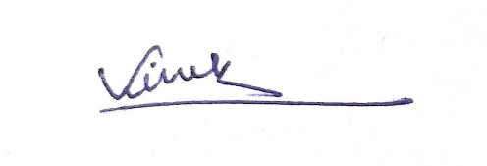

E. Full name | Dr. Rekha Chaudhary
Mobile Number | 9781034569
Email | rekha.ceeri@gmail.com
UID/Registration Number | 30192
Address of internal Affiliations | Lovely Professional University, Punjab-144411, India
Signature (Mandatory) | 

PROBLEM ADDRESSED BY THE INVENTION:

- Electric power distribution networks continue to experience significant non-technical losses, a major portion of which arises from unauthorized consumption of electricity. Conventional metering systems are primarily designed to record energy usage at the consumer end, without maintaining any direct correlation with the actual power supplied at the distribution line. As a result, these systems are inherently incapable of identifying discrepancies caused by illegal tapping, meter bypassing, or partial diversion of electrical load.
- Existing smart metering solutions attempt to address this issue through centralized monitoring and cloud-based analytics. However, such approaches introduce multiple limitations. They depend heavily on continuous internet connectivity, which is often unreliable or unavailable in rural and semi-urban regions. Additionally, centralized systems increase infrastructure cost, latency, and vulnerability to network failures.
- Another critical limitation is the absence of real-time comparative analysis between supply-side and consumption-side measurements. Without a reference measurement at the distribution line, it becomes difficult to determine whether the recorded consumption accurately reflects the actual energy delivered.
- Furthermore, current solutions do not provide a cost-effective and scalable method to detect localized theft events occurring between the distribution point and the consumer premises. Most systems also lack the capability to perform local processing, relying instead on remote servers for anomaly detection, which delays response time and reduces reliability.
- Therefore, there exists a need for a distributed, low-cost, and real-time energy monitoring system capable of detecting electricity theft by directly comparing supplied and consumed power at multiple points within the distribution network, while operating efficiently even in low-connectivity environments.

OBJECTIVE OF THE INVENTION :

- The primary objective of the present invention is to develop a distributed smart energy monitoring and power theft detection system capable of identifying discrepancies between supplied and consumed electrical power in real time using a low-cost embedded architecture.
- A further objective of the invention is to implement a dual-node measurement approach, wherein electrical parameters are independently monitored at both the supply line and the consumer end, thereby enabling direct comparison of energy flow across the distribution segment.
- Another objective is to enable edge-level data processing using microcontroller-based nodes, such that power calculations and anomaly detection can be performed locally without reliance on centralized cloud infrastructure or continuous internet connectivity.
- An additional objective of the invention is to integrate long-range wireless communication between distributed nodes and a central gateway using low-power radio frequency modules, ensuring reliable data transmission in geographically dispersed or infrastructure-limited environments.
- A further objective is to design a system capable of detecting unauthorized energy usage, including illegal tapping, meter bypassing, and partial load diversion, by evaluating mismatches between measured input and output power values.
- Another objective is to provide a cost-effective and scalable solution that can be deployed across rural and urban power distribution networks without requiring significant modifications to existing infrastructure.
- An additional objective is to enable real-time alert generation upon detection of abnormal conditions, thereby allowing prompt corrective action by utility providers or system operators.
- A further objective is to ensure that the system operates with high reliability and minimal computational overhead, making it suitable for embedded implementation using resource-constrained microcontrollers.

STATE OF THE ART/ RESEARCH GAP/NOVELTY:

Sr. No. | Patent No. | Abstract | Research Gap | Novelty
1. | US20160161539A1 | A method, system, and apparatus for detecting electricity theft are disclosed. Electricity theft is the practice of stealing electrical power from a provider. Violators are not charged for the total number of kilowatt-hours actually used, causing lost revenue for both utility companies and retail electricity providers. The method, system, and apparatus may comprise providing power to a plurality of end user destinations from one power source, selecting one destination for testing, and switching off all of the end user destinations except for the selected destination. The method, system, and apparatus may further comprise sensing the current from the power source, sensing the current returning from the selected destination, and determining the difference. The presence of electricity theft can be determined if the current entering the system is not the same as the current returning from the system. | Lack of Real-Time  Monitoring  1.Existing system  Operates on periodic  testing  2.No continuous  detection of theft  events.  Dependency on Supply  Interruption  1.Requires  disconnection of  multiple users.  2.Not suitable for  uninterrupted power  systems.  Absence of Precise  Theft Localization  1.Detects mismatch but cannot identify exact theft point  2.Leads to inefficient inspection processes | 1.Real-Time Continuous  Monitoring  Unlike US20160161539  A1, which relies on  intermittent testing,  the proposed system  enables continuous real  -time detection of  electricity theft.  2.Non-Intrusive Detection  (No Power Cut Required)  Eliminates need to isolate  consumers  Works without  interrupting supply  3.Precise Theft Localization  Uses distributed sensors  / node-based monitoring.  Identifies exact location  of theft.
2. | IN-217710 | The present invention provides a power theft detection system in an electricity distribution network comprising: a server provided at the power station, said server is connected to plurality of nodes that provide power to the pole network under the control of said power station, each pole of said network is provided with a pole meter having plurality of electricity measuring units and at least one electronic device for storing the data of said measuring units, said electricity measuring units are connected to corresponding power line to the end user's electricity meter, the arrangement between the electricity measuring units and said electronic device being such that the electronic device stores the data of said measuring units and transmits to the server where the data of user's electricity meter is compared with the data of said measuring units to detect the theft. | The existing system described in IN217710 relies on a static comparison mechanism between pole-level electricity measurements and consumer meter readings. While it provides a basic framework for identifying discrepancies, it suffers from several critical limitations:  - Lack of real-time monitoring, resulting in delayed detection of theft activities.  - Absence of precise fault localization, making it difficult to identify the exact source of unauthorized consumption.  - Inability to differentiate between technical losses and actual theft, leading to inaccurate detection and false alarms. | The proposed system introduces significant advancements over existing systems IN217710 by incorporating:  1.Real-time IoT-based monitoring  Continuous data transmission using smart sensors  Instant detection instead of delayed analysis  2.AI-based anomaly detection  Machine learning models to identify abnormal consumption patterns  Differentiation between technical loss and theft  3.Granular theft localization  Node-level or segment-level detection  Pinpointing exact theft location
3. | EP3704502A1 | The present subject matter enables early or real-time detection of anomalies in electric networks. In various applications, the system detects anomalies, such as electricity theft, electricity surge, etc. It solves the difficult-to-detect problems in an electrical network, where anomalies like electricity theft or electrical surge may not be found until it has raised numerous concerns or complaints, or has created a significant impact on infrastructure functionality, service quality, or cost. In addition, the present subject matter decreases the requirement for large number of sensors and provides more cost effective and scalable solutions. The present subject matter provides a method for determining where a detected anomaly is occurring within an electrical network. Variations of the present subject matter include anomaly identification systems for addressing anomalies in large networks. Various applications of the present subject matter provide guidance or effective placement of sensors in the electrical network. | Despite advancements presented in EP3704502A1 for anomaly detection in electrical networks, several limitations remain:  1.The system primarily focuses on network-level anomaly detection and lacks fine-grained consumer-level monitoring.  2.It operates as a reactive system, identifying anomalies after occurrence rather than predicting them in advance.  3.The approach emphasizes sensor placement optimization but does not incorporate multi-sensor data fusion for enhanced accuracy. | 1.Multi-Layer Detection System  Unlike EP3704502A1, the proposed system performs anomaly detection at both network-level and consumer-level, enabling fine-grained identification of theft sources.  2.AI-Based Predictive Model  The system incorporates machine learning algorithms to predict abnormal consumption patterns before actual theft or surge occurs.  3. Edge + Cloud Hybrid Architecture  Detection is performed using edge devices for real-time response and cloud systems for deep analysis, reducing latency and improving scalability.

DESCRIPTION OF THE INVENTION:

The present invention discloses a distributed smart energy monitoring and power theft detection system designed to identify discrepancies between electrical power supplied at the distribution level and power consumed at the end-user level. The system is composed of two intelligent sensing nodes and a central processing gateway interconnected through long-range wireless communication.

- SYSTEM CONFIGURATION
The system consists of the following functional units:
1. Line Monitoring Node (Node 1)
The line monitoring node is installed at the supply side, such as an electric pole or distribution line. This node is responsible for measuring the total electrical power delivered to a specific consumer segment.
The node incorporates:
- A current sensing module for measuring line current
- A voltage sensing module for measuring supply voltage
- A microcontroller unit for signal processing and power computation
- A wireless communication module for transmitting processed data
The voltage and current signals are continuously sampled and converted into digital values. The microcontroller processes these values to compute real-time electrical parameters including instantaneous power.

2. Consumer Monitoring Node (Node 2)
The consumer node is installed at the user premises and performs similar measurements as the line node, but specifically for the consumer load.
This node independently measures:
- Load current
- Load voltage
- Real-time power consumption
The node processes these values locally and transmits the computed power data to the gateway using the same wireless communication protocol.

3. Wireless Communication Layer
Both nodes are equipped with a long-range, low-power wireless communication module based on LoRa technology. This enables reliable data transmission over several kilometers without requiring internet infrastructure.
Each node periodically transmits a structured data packet containing:
- Node identifier
- Measured voltage
- Measured current
- Calculated power value
The communication is designed to be robust against interference and suitable for rural as well as urban environments.

4. Central Gateway Unit
The gateway unit acts as the central processing system of the invention. It receives data from both nodes and performs comparative analysis to determine the presence of anomalies.
The gateway includes:
- A microcontroller with higher processing capability
- A wireless receiver compatible with the node transmitters
- An optional display and alert system
The gateway aggregates incoming data and synchronizes measurements based on time intervals.

- OPERATIONAL MECHANISM
The operation of the system is based on continuous monitoring and comparison of electrical power values.
- The line node measures total supplied power (P₁).
- The consumer node measures total consumed power (P₂).
- Both nodes transmit their respective values to the gateway at fixed intervals.
- The gateway compares the received values using a predefined threshold condition.
If the supplied power exceeds the consumed power beyond an acceptable margin, the system identifies this condition as a potential case of electricity theft.

- THEFT DETECTION LOGIC
The detection mechanism is implemented using a threshold-based comparison algorithm defined as:
If P₁ > (P₂ + Δ)
→ Theft Condition Triggered
Where Δ represents an acceptable margin accounting for transmission losses, sensor inaccuracies, and environmental factors.
This approach ensures that minor variations do not trigger false alarms, while significant discrepancies are flagged for further investigation.

- EDGE PROCESSING CAPABILITY
A key feature of the invention is the use of local processing at each node. Instead of transmitting raw sensor data, each node computes electrical parameters independently. This reduces communication overhead and enables faster detection.
The system is capable of functioning even in the absence of internet connectivity, as all critical decisions are made locally at the gateway.

- ALERT AND RESPONSE SYSTEM
Upon detection of a theft condition, the gateway initiates an alert mechanism. This may include:
- Visual indication through display units
- Audible alerts using buzzer modules
- Transmission of notifications to external systems (optional)
The alert mechanism ensures immediate awareness of abnormal conditions.

- SCALABILITY AND EXTENSIBILITY
Although the current configuration includes one line node and one consumer node, the architecture can be extended to multiple consumer nodes connected to a single line node. This allows the system to be scaled for larger distribution networks.

- ADVANTAGEOUS EFFECTS
The invention provides a practical solution for detecting electricity theft through direct measurement and comparison of power values. It eliminates the need for complex infrastructure and enables deployment in low-resource environments.
The use of distributed nodes enhances accuracy, while long-range communication ensures reliable operation across wide geographical areas.

Block Diagram:

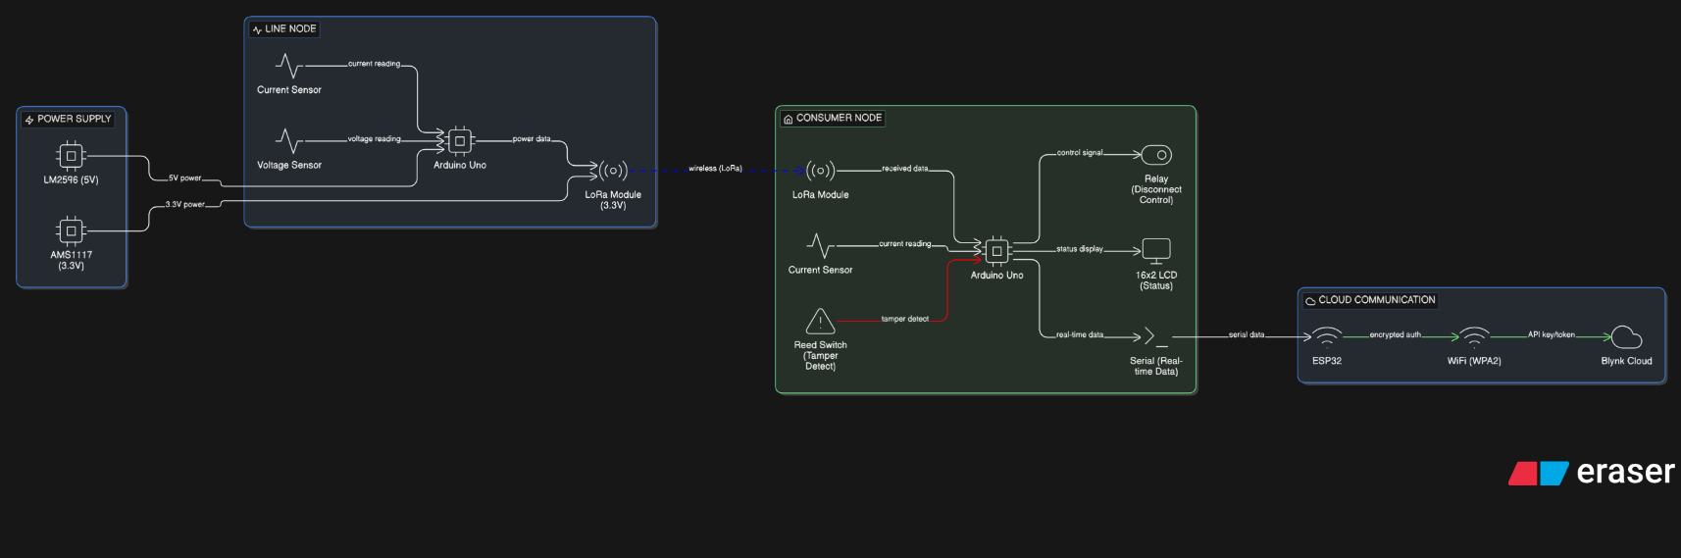

FLOW CHART OF HARDWARE WORKING:
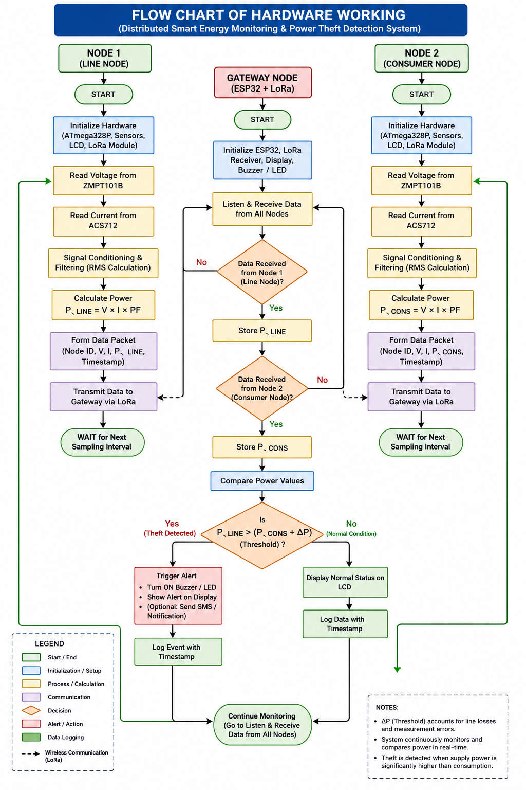

Flowchart Description (Detailed & Precise)
1. System Initialization Phase
Upon power-up, all system components undergo initialization. Each node (Line Node and Consumer Node) configures its microcontroller, sensor interfaces, and communication module.
The analog-to-digital converters (ADC) are configured for voltage and current signal acquisition. The LoRa communication module is initialized with predefined frequency, node ID, and transmission parameters. The gateway node initializes its receiving module and prepares the data processing unit.
A synchronization delay is introduced to ensure stable sensor output before entering the operational loop.

2. Sensor Data Acquisition Phase
Each node independently acquires electrical parameters from the connected sensors.
- The voltage sensing module provides an analog representation of the AC supply voltage.
- The current sensing module outputs a proportional analog signal corresponding to the line current.
The microcontroller samples these analog signals at a defined sampling rate. Multiple samples are collected over a short interval to capture waveform variations and improve measurement accuracy.

3. Signal Conditioning and Processing
The raw analog readings are subjected to signal conditioning and digital processing.
- Noise filtering techniques are applied to remove fluctuations and transient disturbances.
- The signals are normalized and scaled according to calibration constants.
- Root Mean Square (RMS) values of voltage and current are computed to represent effective electrical parameters.
This stage ensures that the system operates on stable and reliable measurements rather than instantaneous noisy readings.

4. Power Computation
Using the processed RMS values, each node calculates the instantaneous electrical power.
The computation considers the product of voltage and current, and may include a correction factor to account for power factor variations in AC systems.
The computed power value is stored temporarily within the node memory for transmission.

5. Data Packet Formation
Each node organizes its computed data into a structured packet.
The packet typically includes:
- Node identifier (Line Node or Consumer Node)
- Measured voltage
- Measured current
- Calculated power value
- Timestamp or sequence number
This structured format ensures that the gateway can distinguish between multiple nodes and process the data correctly.

6. Wireless Data Transmission
The prepared data packet is transmitted from each node to the gateway using the LoRa communication module.
The communication protocol ensures:
- Long-range transmission capability
- Low power consumption
- Minimal data loss
Transmission occurs periodically based on a predefined interval to maintain continuous monitoring.

7. Data Reception at Gateway Node
The gateway node continuously listens for incoming data from the distributed nodes.
Upon receiving a packet:
- The data integrity is verified
- The node identifier is extracted
- The corresponding power value is stored in memory
The gateway maintains separate records for supply-side and consumption-side measurements.

8. Comparative Analysis and Theft Detection
The gateway performs real-time comparison between the received power values.
Let:
- $P_{supply}$= Power measured at Line Node
- $P_{consumption}$= Power measured at Consumer Node
The system evaluates the following condition:
If P_supply > (P_consumption + predefined threshold)
→ Potential electricity theft detected
The threshold value accounts for minor transmission losses and sensor inaccuracies to avoid false detection.

9. Alert Generation and Output Response
If an abnormal condition is detected:
- A visual alert is displayed on the monitoring interface
- An audible or indicator-based alert (buzzer/LED) may be activated
- Optional communication modules may transmit alert data to external systems
In normal conditions, the system continues monitoring without triggering any alert.

10. Continuous Monitoring Loop
After completing one cycle, the system returns to the data acquisition phase and repeats the entire process continuously.
This loop ensures real-time monitoring and immediate detection of any anomaly in power distribution.

Working Hardware pic:

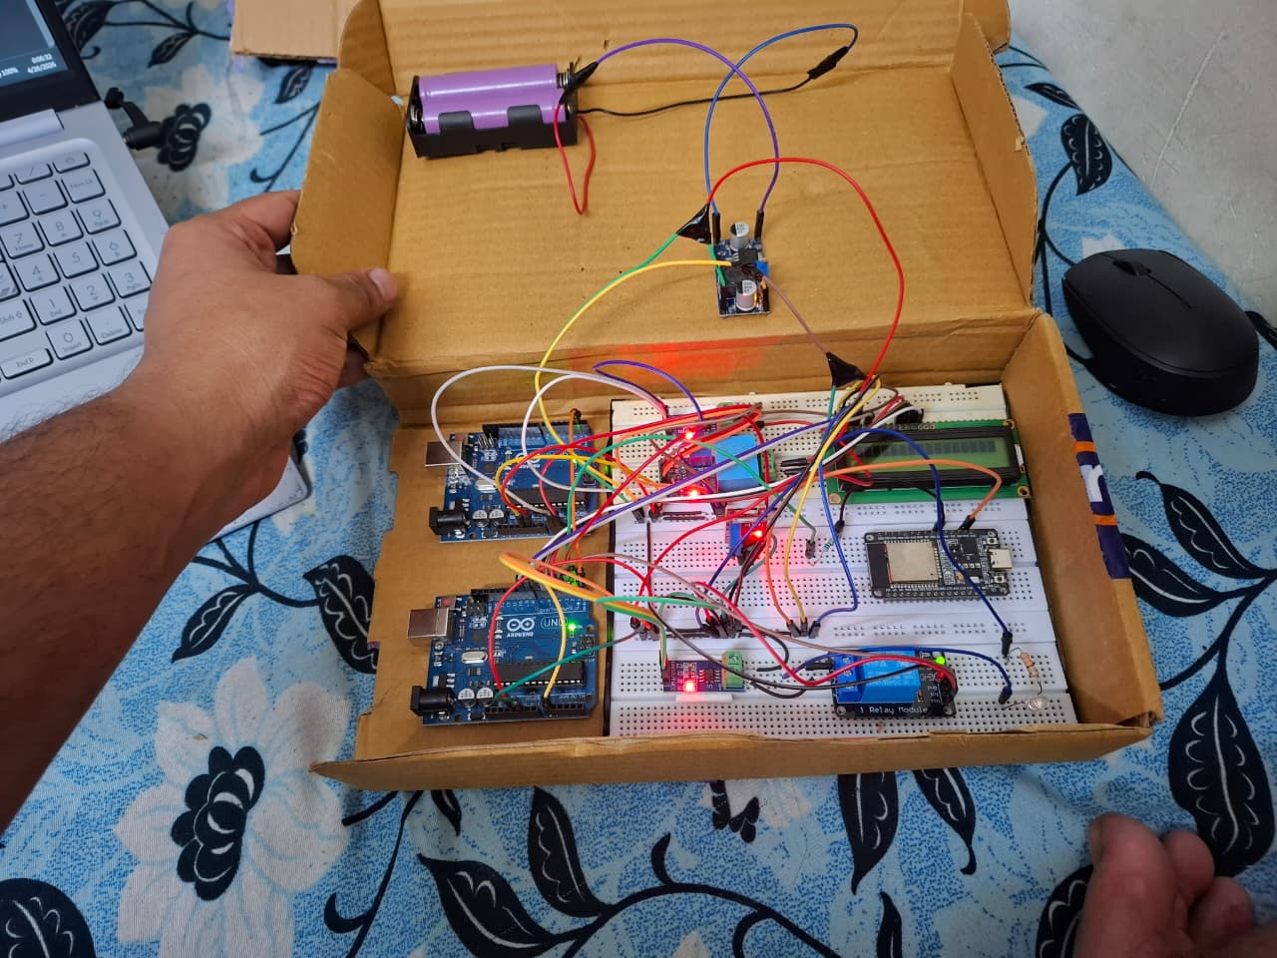
MATHEMATICAL MODEL & EQUATIONS

Electrical Parameter Computation
The system determines electrical parameters based on sampled voltage and current signals.
  - RMS Voltage and Current
$$V_{rms}=\sqrt{\frac{1}{N}\sum_{i=1}^{N}{V_{i}^{2}}} \\ I_{rms}=\sqrt{\frac{1}{N}\sum_{i=1}^{N}{I_{i}^{2}}}$$
Where:
- $V_{i}$, $I_{i}$= instantaneous sampled values
- $N$= number of samples

  - Real Power Calculation
$$P=V_{rms}×I_{rms}×cos⁡ϕ$$
Where:
- $\cos{ϕ}$= power factor (approximated or assumed for resistive loads)

  - Node-Level Power Representation
$$P_{line}=\text{Power measured at Line Node} \\ P_{consumer}=\text{Power measured at Consumer Node}$$

  - Theft Detection Condition
$$P_{line}>P_{consumer}+Δ$$
Where:
- $Δ$= threshold margin accounting for:
  - line losses
  - sensor inaccuracies
  - environmental variations

  - Threshold Adaptation (optional but strong)
$$Δ=k×P_{consumer}$$
Where:
- $k$= tolerance factor (e.g., 5–10%)
CLAIMS SECTION

Claim 1
A distributed smart energy monitoring system comprising:
- a supply-side measurement node configured to measure electrical parameters of a distribution line;
- a consumer-side measurement node configured to measure electrical parameters of a connected load;
- at least one microcontroller configured to process sensor data and compute electrical power;
- a wireless communication module configured to transmit processed data between nodes and a gateway;
- a gateway unit configured to receive data from said nodes, compare power values, and detect anomalies indicative of electricity theft.

Claim 2
The system as claimed in Claim 1, wherein the wireless communication module comprises a LoRa-based long-range communication interface.

Claim 3
The system as claimed in Claim 1, wherein each node performs local computation of electrical parameters including voltage, current, and power prior to data transmission.

Claim 4
The system as claimed in Claim 1, wherein electricity theft is detected based on a threshold comparison between supplied and consumed power values.

Claim 5
The system as claimed in Claim 1, wherein the gateway operates independently of continuous internet connectivity and performs edge-level anomaly detection.

ADVANTAGES OF THE INVENTION

    - Technical Benefits:
The proposed system introduces a distributed architecture that enables direct comparison between supply-side and consumption-side power measurements. This approach improves detection accuracy by eliminating reliance on isolated metering data.
The implementation of edge-level processing at each node reduces the need for transmitting raw sensor data. Instead, processed electrical parameters are communicated, which lowers communication overhead and improves system efficiency.
The use of long-range wireless communication ensures reliable data exchange over extended distances without requiring complex networking infrastructure. This makes the system suitable for deployment across geographically dispersed areas.
The system operates using real-time data acquisition and processing, allowing immediate detection of anomalies. The inclusion of threshold-based evaluation ensures that minor variations due to measurement noise or environmental factors do not lead to incorrect detection.
Additionally, the modular design of the system allows independent operation of nodes, ensuring that failure of one component does not completely disrupt the monitoring process.

    - Practical Benefits:
The system is designed using low-cost and readily available hardware components, making it economically viable for large-scale deployment.
It does not depend on continuous internet connectivity, allowing it to function effectively in rural or infrastructure-limited regions where network availability is unreliable.
The installation process requires minimal modification to existing power distribution systems, which reduces implementation complexity and cost.
The system provides real-time alerts upon detection of abnormal conditions, enabling quicker response and reducing revenue losses caused by electricity theft.
Due to its simple architecture and low computational requirements, the system is easy to maintain and can be operated by personnel with basic technical training.

INDUSTRIAL APPLICATION
The proposed invention can be applied in various sectors of the power and energy industry.
It is particularly suitable for power distribution companies to monitor energy flow across feeder lines and detect unauthorized consumption in real time.
The system can be deployed in rural electrification projects where conventional smart grid infrastructure is not feasible due to high cost or lack of connectivity.
It can be used in residential and commercial energy auditing to verify the accuracy of energy consumption and detect discrepancies between supply and usage.
The invention is also applicable in industrial environments where monitoring of distributed loads is required to ensure efficient energy utilization and prevent losses.
Furthermore, the system can be integrated into future smart grid frameworks to enhance monitoring capabilities and improve reliability of power distribution networks.

ERROR HANDLING AND RELIABILITY
To ensure consistent and accurate operation, the system incorporates mechanisms to handle potential errors and uncertainties.
Sensor readings are collected over multiple sampling cycles and averaged to minimize the effect of noise and transient fluctuations. This improves the stability of measured electrical parameters.
The system includes tolerance margins in the comparison logic to prevent false detection caused by minor variations due to environmental conditions or sensor inaccuracies.
In cases where communication between nodes and the gateway is temporarily disrupted, the system retains the last valid measurement and resumes operation once communication is restored.
Data integrity checks are applied to received packets to ensure that corrupted or incomplete data does not affect the comparison process.
The system is designed to operate continuously under varying conditions, maintaining reliable performance without requiring frequent recalibration.

SCALABILITY AND FUTURE SCOPE
The architecture of the proposed system allows easy expansion by adding multiple consumer nodes connected to a single supply-side node.
This scalability enables the system to be deployed in larger distribution networks, including residential clusters, commercial complexes, and industrial setups.
Future enhancements may include integration with advanced data analytics techniques to identify consumption patterns and predict potential anomalies.
The system can also be extended to support remote monitoring through cloud-based interfaces, providing centralized control while retaining edge-level processing capabilities.
Additional features such as automated load control, predictive maintenance, and integration with renewable energy sources can further enhance the functionality of the system.
The modular design ensures that future upgrades can be implemented without significant changes to the existing setup.

CONCLUSION
The proposed distributed smart energy monitoring and power theft detection system provides an effective solution for identifying discrepancies between supplied and consumed electrical power.
By utilizing a dual-node measurement approach and real-time comparison at the gateway, the system enables accurate detection of unauthorized energy usage.
The use of edge-level processing and long-range wireless communication ensures reliable operation even in environments with limited connectivity.
The system offers a balance between cost, performance, and scalability, making it suitable for practical deployment across a wide range of power distribution scenarios.
Overall, the invention addresses key limitations of existing systems and provides a technically sound and implementable approach for improving energy monitoring and reducing non-technical losses.

